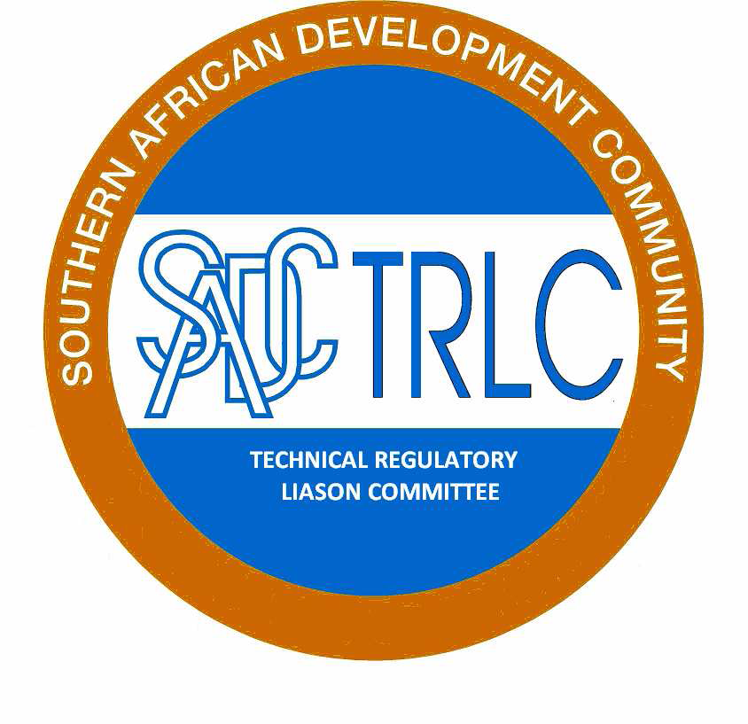



**Minute Report**

**SADCTRLC Expert WG meeting**

**Date: 12 March 2016**

**Venue: Gaborone, Botswana (Phakalane Golf Estate Hotel Resort)**

**ATTENDEES**

The following participants attended the expert Working Group Meeting. The participants were representative form the SADCTRLC Secretariat and SADC Secretariat.

Mr Johannes Mosabawe - (SADCTRLC Chairperson)

Mr Innocent Sbusiso Khumalo - (SATRLC Secretariat)

Ms Anna-Marie Lotter – (SADCTRLC Regional Coordinator)

Mr Moses Ngosa – (SADCTRLC Member)

Mr Elias Kansembe – (SADCTRLC Member)

Ms Phindile Dlamini – (SADCTRLC member)

Ms Zukiswa Raditladi – (SADCTRLC member)

Ms Kuena Molapo – (SADC Secretariat)

The invitation letter and attendance registers are enclosed.

**INTRODUCTION**

The meeting was officially opened by word of prayer by Phindile Dlamini. The SADCTRLC Chairperson welcomed members to the meeting opened and introduced the purpose of the meeting. The draft agenda was amended by adding an item on Rules of procedures.

The meeting noted an apology from Zambia on behalf of Mr. Moses Ngosa.

The meeting reflected on SADCTRLC Annual General Meeting Resolutions March 2015 as follows:

* The meeting noted that Resolution 2/2015 is still outstanding and propose to source funding from PTB to implement this resolution. The meeting agreed that this resolution to be considered as an agenda item for the proposed April 2016 Expert Working Group (EWG).
* The meeting noted the Resolution 3/2015 as done with an exception that the concluded Baseline Study on Technical Regulations affecting trade needs to be validated with Member State that participated in the study. The meeting noted the progress made in terms of model that will be used to harmonize Technical Regulations in the region. The EWG will pilot the model during the meeting planned for the month of April 2016. The model will be presented in the SADCTRLC Annual General Meeting.
* The point above gave rise to issue related to participation and commitment of MSs in the work SADCTLRC. The meeting discusses the matter at length and the concluded the following recommendations:
* Individual engagement with the MS in question
* Task the SADCTRLC Chair and SADC Secretariat to compile a letter to facilitate and encourage participation of the MSs to the SADCTRLC structure.
* This challenge to be tabled to the SADCTBTEG meeting for discussion and solution/s.
* The meeting recorded the Resolution 4/2015 as done encourage MSs to visit the SADCTRLC website. The meeting agreed that all work and communication of the SADCTRLC will be on SADTRLC website.
* The meeting concluded Resolution 5/2015 as done. The meeting noted that 10 MSs participated in the RIA training excluding Mauritius. The meeting considered that further training is important to extend it to MSs that did not participate in the said RIA training. The meeting agreed to standardize the RIA training slides for uniformity in the process of information dissemination. The meeting noted that the heading of the document is not aligned with the training materials. Matters related to logistical arrangements for MSs will be table before PTB for considerations.
* The meeting noted Resolution 6 as done and recommends that it is posted in the SADCTRLC website.
* The meeting noted Resolution 7 as done encouraged MSs to visit and use the SADCTRLC website.
* The meeting reported that Resolution 8 is done. The survey was sent to all MSs however not all MSs responded. The survey is to determine the implementation status and needs assessment of member states regarding GHS during April 2015. The survey results will then inform the coordinated programme to further assist with the GHS implementation. SADCTRLC Secretariat will contact both PTB and Africa Institute in the month of April 2015 to discuss matters relating to GHS. PTB was approached and agreed to assist however request that the MSs applies by using PTB application form. The application form was sent to MSs. MSs has submitted and outstanding MSs are encouraged to submit.
* The meeting noted Resolution 9 that only six (6) MSs that submitted their annual country reports. The meeting discuss the matter at length consider the following recommendations:
* Individual engagement with the MS in question
* Task the SADCTRLC Chair and SADC Secretariat to compile a letter to facilitate and encourage participation of the MSs to the SADCTRLC structure.
* This challenge to be tabled to the SADCTBTEG meeting for discussion and solution/s.
* Align the annual country report with the plan of the MSs.
* The SADCTRLC Annual General Meeting to go through the template of the of annual country report.
* Alert System, Resolution 10: The SADCTRLC Secretariat provided the progress report in terms of project with Swedac. The report indicates that Swedac was not too keen to assist with the project since the Technical Regulations in the SADC region are not yet harmonised. The rationale is such that it will be difficult to implement in the absence of harmonised Technical Regulations.
* The SADCTRLC secretariat tabled three alternative options aimed to continue with the project without the assistance from Swedac. The following summary summaries the three options:
  + **Option One (1):** That, the SADCTRLC continues with the project and use the SADCTRLC website platform. The meeting agreed that the process will be such that the SADCTRLC approach PTB to expand the scope of the SADCTRLC website via the NMISA assistance. The website will incorporate the interactive page that will allow MSs to communicate non-compliant products in the SADC region. The project or ToR proposal shall be developed upon the principal concurrent with PTB.
  + **Option Two (2):** That, the SADCTRLC develops a new website strictly dealing with the non-compliant products in the SADC Region. This option did not gain positive support from the meeting.
  + **Option Three (3):** That, the SADCTRLC uses the Non-Tariff Barrier (NTB) Notification Focal Point. The meeting discussed the option at length and noted that there are challenges with it arising from the fact it is organized at the COMESA-EAC-SADC level. The SADCTRLC will further consult on this approach.
* The meeting agreed that option one is practical and will give SADCTRLC more control on the proposed project and the associated work.
* The SADCTRLC EXCO meeting noted the progress made with respect to the Second Hand Tyre Project, Resolution 11, and agreed that the outstanding work to be finalized during the month of April 2016. The meeting noted that only one MSs commented on the concept paper and encourage that all MSs to comment on the paper

The meeting noted Resolution 13 as done.

The meeting considered Resolution 14 and concluded that following:

That, Swaziland is available for Vice Chairperson Position;

That, Botswana is available for Membership Position;

That, Namibia is available for Membership Position;

That, Botswana will confirm its availability in terms of Chairperson Position; and

That, South Africa will volunteer for the SADCTRLC Secretariat and SADCTRLC Regional Coordinator in absence MSs availability.

The meeting noted Resolution 15 as done.

The meeting was adjoined at 14H20

**CLOSURE**

The meeting was adjourned on the 12th of March 2016 with a view to implement the above-mentioned action plan.

|  |  |  |
| --- | --- | --- |
| Mr I. S. Khumalo  SADCTRLC Secretariat  ……/……./2016 | Ms A. Lotter  SADCTRLC Regional Coordinator  ……/……./2016 | Mr Johannes Mosabawe SADCTRLC Chairperson  ……/……./20156 |